**Project 2 - Noisy Elliptical Dots**

Screenshot:

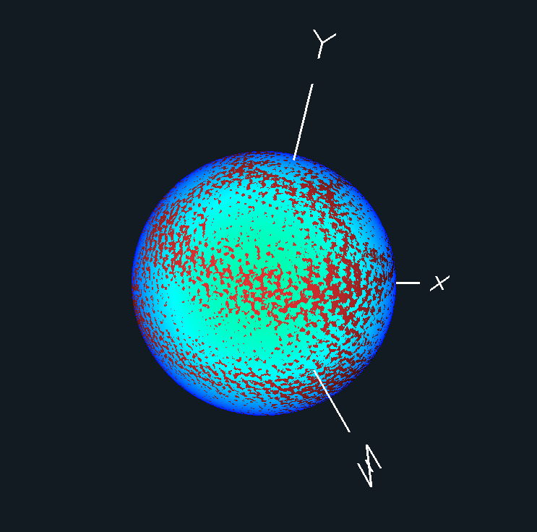

Video Link:<https://media.oregonstate.edu/media/0_xxg2ckyv>

Thanks, and have a great day!